GUIDE TO THE ‘SC’ TEMPLATE (‘SC-PAPER-TITLE’ 16PTS)
First Author¹, Second Author² and Third Author*¹ (‘SC-Paper-Authors’ style)
¹Affiliation of First Author and Third Author (‘SC-Paper-Affiliation’ style)
²Affiliation of Second Author
Received: dd/mm/yyyy  Accepted: dd/mm/yyyy | Corresponding author: Third Author (email@somewhere.com)
- ABSTRACT
The abstract must be between 200 and 300 words written in ‘SC-Abstract’ style.
Scientific Culture is a peer-reviewed, open access international scientific journal, an open information vehicle of academic community with a global coverage and issues touching local and regional interest; it is intended as a starting point for presenting research devoted in the broad field of diachronical Cultural Heritage. The journal provides a broader coverage of studying ancient cultures with natural sciences focused on specific topics of global interest. Amongst the published themes emphasis is given to: Ancient cultures; hidden information in art by symbolism; composition of artifacts; parallels in ancient and recent cultural issues; the role of liberal arts to cultural background; cultural development and the question of independent, autochthonous, interactive patterns; theoretical approaches: archetypal concept and globalization effects; inter-, intra-settlement and environmental interactions on cultural evolution; art and science, virtual culture, cognitive archaeology via positive sciences etc.

KEYWORDS: Up to 8 comma-separated keywords or key phrases.

- INTRODUCTION
For consistency in producing your document you are advised to use this template and directly insert your text in this document.
It is advised that you keep in mind the following guidelines:
- Keep the order of the document sections as provided in this template: Title, names, affiliations, keywords, abstract, sections, acknowledgements, references.
- Do not leave any spaces at the beginning of each paragraph. The template takes care of paragraph spaces.
- DO NOT replace large pieces of the template with parts of your paper (i.e. do not just copy-paste the whole paper from your document at once). Type in the appropriate parts and sections following font sizes and styles.
- Headers/Footers: Type in the required data of first author’s surname and running title in the header as guided by this template. This is required to occupy just one single line. Keep footers unchanged (“SCIENTIFIC CULTURE, Vol. X, No. X, (20xx), pp. xx–xx”).
- Received: dd/mm/yyyy: Set the date you submitted the paper.
- For figures and tables see next chapter
- Bullets and numbered text use the styles ‘SC-List (unnumbered)’ and ‘SC-List (numbered)’ respectively
- Hyphenation is active and automatic
- Take care not to delete the section breaks before the Introduction and before the References in order to keep the proper page format.
- Do not leave extra paragraph spaces, except in the following cases:
  - One extra paragraph space is needed before each Figure.
  - One extra paragraph space is needed before and after each Table.
- FIGURES AND TABLES
Figures should be centred in the column. Figure format is ‘SC-Figure’ whereas table format is ‘SC-Table-Text’. The figure legend should be placed below the figure using the SC-Figure-Caption style and can be automatically assigned by using the Insert > Caption option (either from the tab-bar or from the menu), or the Insert > Reference > Caption in earlier versions of MS Word. All figures should be referenced in the text (as shown in Figure 1). The automated “cross-reference” system could be used, so that figure numbers are automatically tracked and updated. See the following subsection for detailed info on how to use the automated captioning system of MS Word. This also applies to tables.
Tables, just like figures should be captioned and styled with SC-Table-Caption as shown in Table I. Table captions are placed above the table and centred. Tables must also be referenced in the text, either manually or by using the ‘Cross-reference’ function of the word processing software (just like in the case of figures). Tables should have one paragraph space before and one after.
In cases that a figure or table should occupy the entire width of the page then proceed as follows:
- insert the figure/table and caption
- select both figure/table and caption
- click on ‘One column’ from the tab-bar (or use the menu Format > Columns > One)
MS Word should automatically insert a section break before and one after the selected text and the figure/table and caption should be displayed in one column. See Figure 2 for an example. The same would apply to a case of a table.

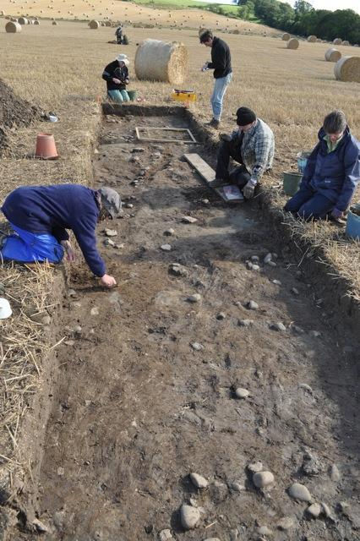
Figure 1. This is an automated figure label
Table I. This is the table caption
Head 1 | Head 2 | Head 3 | Head 4 | Sum
1 | 1 | 1 | 1 | 4
2 | 1 | 2 | 2 | 7
3 | 2 | 2 | 2 | 9
4 | 2 | 3 | 2 | 11
5 | 3 | 3 | 3 | 14
  - Auto cross-referencing figures/tables
When using MS Word for Windows:
- Move the cursor in the position to insert the reference
- Go to the ‘Insert’ tab and select (click) Cross-reference (link section) – in earlier versions of MS Word this is Insert > Reference > Cross-reference.
- Choose the type of referencing item, like the headings, the numbered items, figures, or tables. To reference figures, select figures and change the “Insert reference to:” option to “Only label and number”. Similar steps should be followed for the case of tables
- Click Insert to complete the referencing and either close the dialog box or insert another reference
When using MS Word for Mac OS:
- Select Insert > Cross-reference from the menu
- Execute the steps 3-4 defined for Windows
    - Sub-subsection level 3
Use SC-Heading-3 style for sub-subsections: Book Antiqua, 11, bold. Spacing should be 14 points before and 4 points after.

Figure 2. This is the figure legend of a single column figure

      - Sub-Sub-Subsection Level 4
Use SC-Heading-4 style for sub-sub-subsections: Book Antiqua, 11, underline. Spacing should be 14 points before and 4 points after.
Do not use sub-sections deeper that level 4.
- REFERENCES
References should be again in single column format and provided in alphabetical ordering starting with the first author’s surname and all names capitalized. Use the SC-Reference style for references, which corresponds to Book Antiqua 9pts, 0.75 hanging indentation. To use references in the text use the following example (Bilda et al., 2003; Walker, 2012).

Author Contributions: For research articles with several authors, a short paragraph specifying their individual contributions must be provided. The following statements should be used “Conceptualization, X.X. and Y.Y.; methodology, X.X.; software, X.X.; validation, X.X., Y.Y. and Z.Z.; formal analysis, X.X.; investigation, X.X.; resources, X.X.; data curation, X.X.; writing—original draft preparation, X.X.; writing—review and editing, X.X.; visualization, X.X.; supervision, X.X.; project administration, X.X.; funding acquisition, Y.Y. All authors have read and agreed to the published version of the manuscript.” Please turn to the CRediT taxonomy for the term explanation. Authorship must be limited to those who have contributed substantially to the work reported.

ACKNOWLEDGEMENTS
Sample text: We thank the anonymous reviewers for their constructive comments. This work was partially supported by the 7th Framework Programme “Project Name” funded by the EU within the Reflective Societies Work Programme 2014-2010. The authors would especially like to thank the personnel of the Research Centre for their support and technical cooperation.
- REFERENCES
Binda, L., Saisi, A., Tiraboschi, C., Valle, S., Colla, C. and Forde, M. C. (2003) Application of sonic and radar tests on the piers and walls of the Cathedral of Noto. Construction and Building Materials, Vol. 17, 613–627.
Cosentino, P. and Martorana, R. (2001) The resistivity grid applied to wall structures: first results. Proceedings of the 7th Meeting of the Environmental and Engineering Geophysical Society, European Section, Birmingham, U.K.
Walker, A. (2012) The Emperor and the World: Exotic Elements and the Imaging of Middle Byzantine Imperial Power, Ninth to Thirteenth Centuries C.E. New York, Cambridge University Press.

It is advised to keep footnotes to a minimum.

